Lab 9 – Migrate SQL Server Database from on-premises SQL Server database to Azure SQL database

In this lab, you’ll be creating first Azure SQL Server through Azure portal. Then will migrate SQL Server database from on-premises server to Azure.
- In this Azure portal, search for Azure SQL and select SQL Logical server to create Azure SQL server.
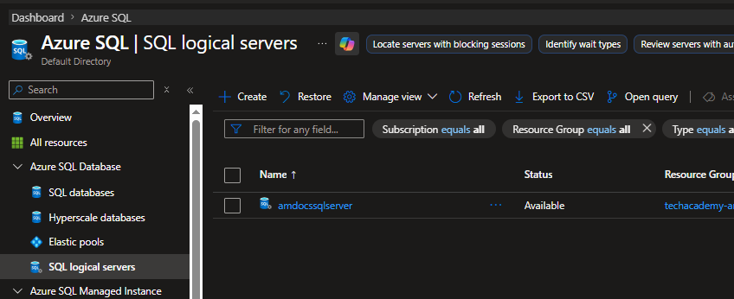

- Next, provide the details like Azure SQL server name, region, the authentication type as SQL authentication and credentials.
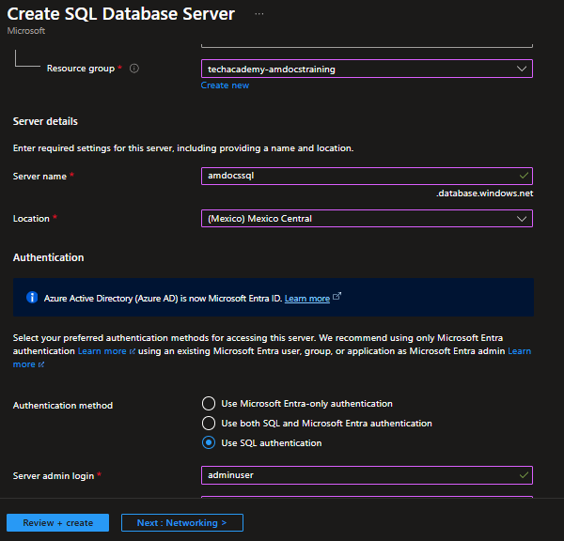

- Under networking tab, click on option “Allow Azure services to access this server” & then click on review and create.
- Once the SQL server on Azure is deployed, go to Networking tab and allow your local IP whitelisting.

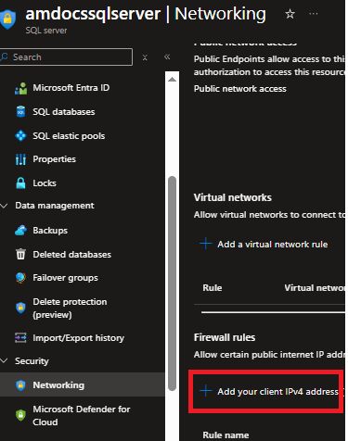

- Now, restore the “TalispinToys2020-US” database from the available backup from this Github repo link.
https://github.com/imcuteani/SQL_Server_Azure_Data_Engineering/blob/main/Labs/day-5/TailspinToys2020-US.bak

- Now, connect to SSMS and click on the following option to start migrate this database to Azure SQL server. Under Tasks, select “deploy to Azure SQL database”.
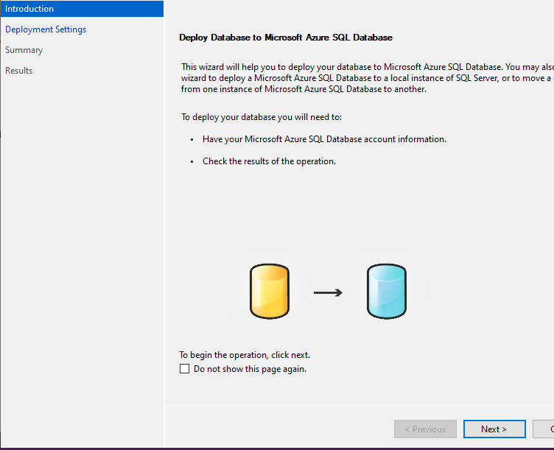

- Next, connect to Azure SQL server by clicking on the “Connect” button and provide the credentials of Azure SQL server just deployed through portal.

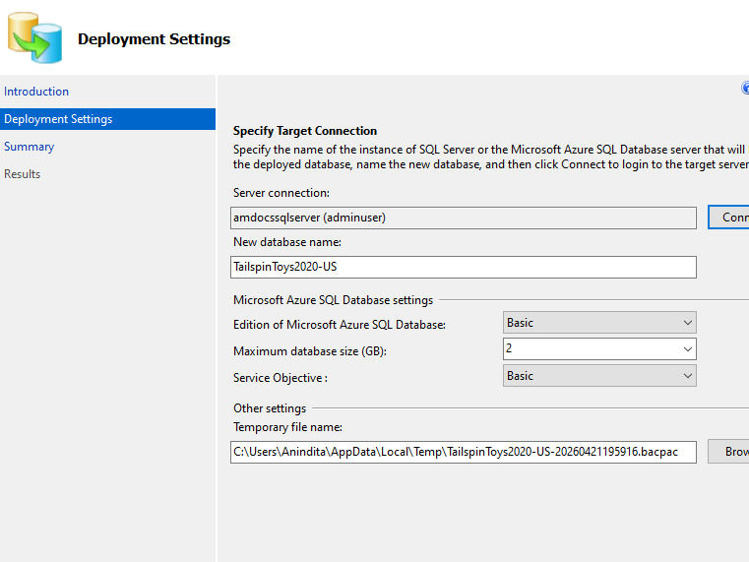

- Now, click on “Next” to proceed to database migration automation scripts and schema and tables.
- Once, it’s completed, the database will be available on Azure.

